
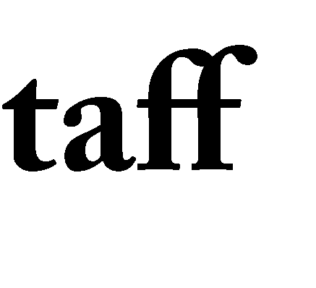

If a member of staff has gone the “extra mile” to support your child, simply fill in this card and return it to the School’s Main Office.
P
S

Member of staff ……………………………………………………………...

In what way have they gone the “extra mile”?
.…………………………………………………………………………………
PVA
STAFF STARS
………………………………………………………………………………….
………………………………………………………………………………….
………………………………………………………………………………….
………………………………………………………………………………….
………………………………………………………………………………….
………………………………………………………………………………….

Date …………………………………………………………………………...

Your Name ……………………………………………………………………

Relationship to the Academy ……………………………………….....…...

Email (optional) ...…………………………………………………………….

